Reports
Reports can be accessed from a Project's overview (accessed from the projects menu) in the 'Summary' tab.
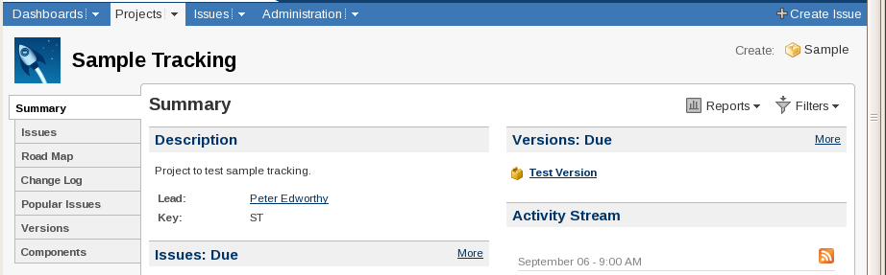

Project Summary and Reports Menu

The reports menu is in the top right hand corner of the page
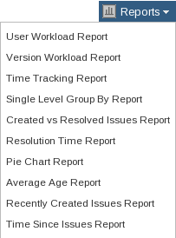
Reports drop-down menu

Creating a report on the quantities of samples in each state:

Method 1: Pie Chart Report
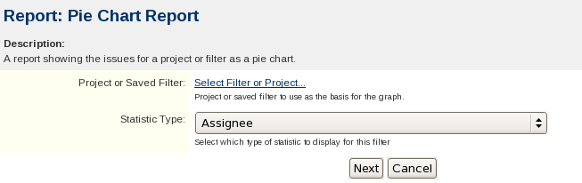
Pie Chart Creation Dialog
Project or Saved Filter:
This can be set to project (to include all the Issues and Sub-tasks in the Project), or a pre-saved filter that selects only the samples required.
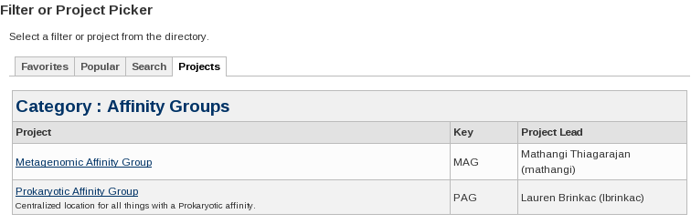
Project or Saved Filter
Statistics Type:
Set to Status

Which produces the following pie chart
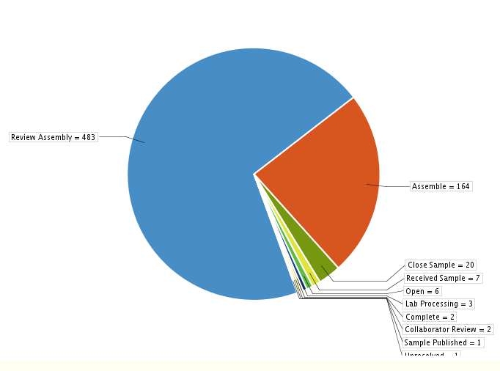
Report: Pie Chart Report, Project: Sample Tracking (Status)

Storing Reports
JIRA doesn't have any native way to store charts or their settings. The charts produced can be saved as images by right clicking on them and selecting 'Save Image As...' from the menu. If there is a graph that is useful to generate regularly the settings can be saved by bookmarking the page that the graph is shown on. Returning to the bookmarked page will cause the graph to be re-drawn with the current information.
A summary table is also produced
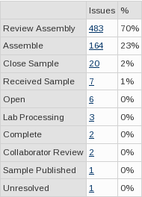
Summary for the above chart
The summary table is very similar to the output of ctmbacs. The example table includes the extra states of Open and Complete as sub-tasks have also been included. Using a filter instead of a Project would allow Sub-tasks to be excluded.

Method 2: Single Level Group By Report
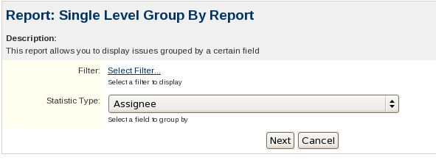
Single Level Group Report Creation Dialog
Filter:
Unlike the filter selector for Pie Charts there is no option it directly pick a project but a Filter that only selects the project can be created if needed.
Statistic Type:
Set to 'Status'
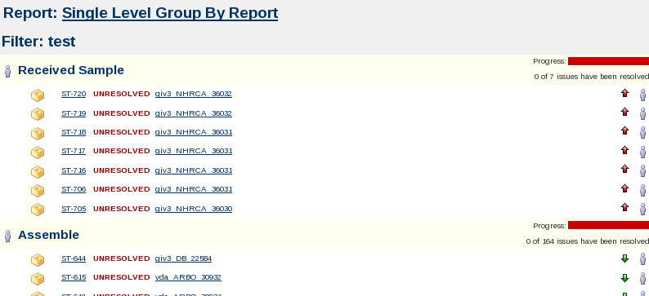
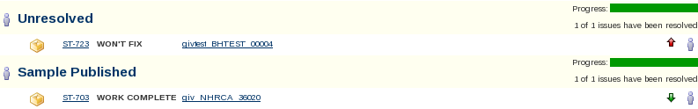
Single Level Group By Report of Samples in Sample Tracking by Status
The output of the report is somewhat verbose but it does include all of the data
Below the progress bar the total number of issues in that group is listed (7 for Received Sample). The progress bar and 'resolution' column are not very useful here as the states map to the completion or otherwise of the sample. Each step will have 100% of the samples in it mapped to the same resolution.
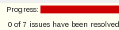

WARNING:
Unresolved in the 1st screen shot of the report is not the same as the state Unresolved in the second screen shot. Unresolved is what Atlassian have decided to print if an Issue or Sub-task has not been closed.
The group headings link to Issue Navigator with a query that will select only that group of samples.

Method 3: Project Overview, Issues
The 'Project Overview' page has a bar graph under 'Issues' which contains the same information as the Pie Chart from Method 1 did. (It also includes sub-tasks as well as Samples). The Status' Names are links to the Issue Navigator. Clicking on them opens the Issue Navigator with a query that will select only Issues from the current project with that status.
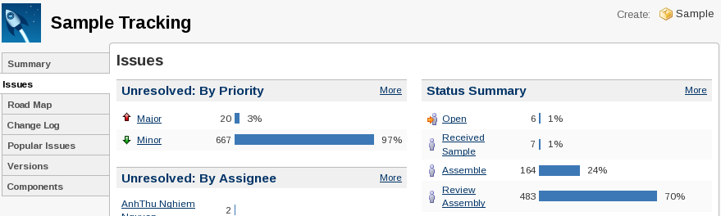
Project Overview - Issues - Status Summary

Method 4: Dashboard Gadget
JIRA has pages similar to the Project Overview tabs that are created by a user for themselves. The various graphs and lists are generated by Gadgets. Under the 'Dashboard' drop down select 'Manage Dashboards' to bring up the 'Manage Dashboards' page.
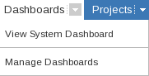

Dashboards drop-down menu
Next select 'Create new Dashboard'
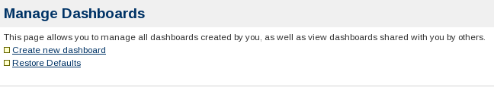

Manage Dashboards page
The only required field for creating as dashboard is name, all the others can be left blank or as their defaults.
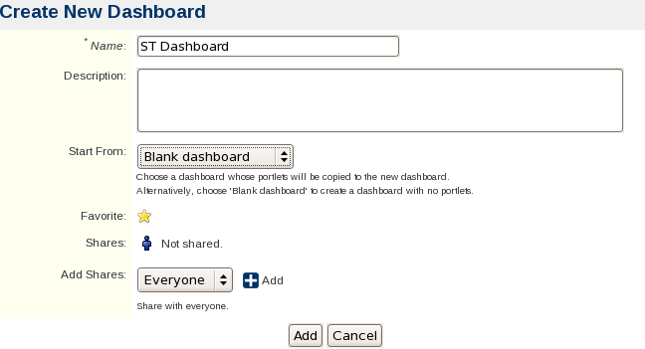
Create Dashboard form
The newly created dashboard can be accessed via its entry on the 'Manage Dashboards' page or via the Dashboards drop-down menu
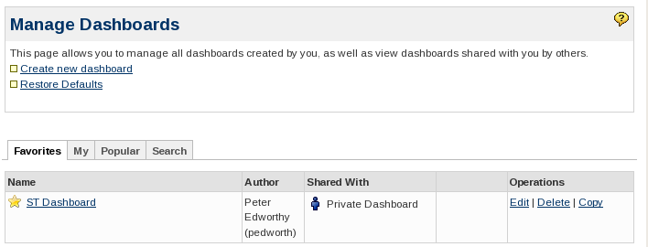
Manage Dashboards Screen, after the dashboard has been created
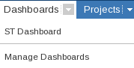
The Dashboards drop-down with the new Dashboard
The dashboard will initially contain only two dashed areas with 'Drag your gadgets here or add a new gadget' written in them. On the top are three icons, 'Add Gadget', 'Edit Layout' and 'Tools'.
Dashboard Icons
Clicking the Add Gadget Icon, or the link in the dashed boxes, brings up the selector for Gadgets. There are a confusing number to choose between. Enter 'issue statistics' in the search box to find the gadget needed. Then click the 'Add it Now' button and then 'Finished'.
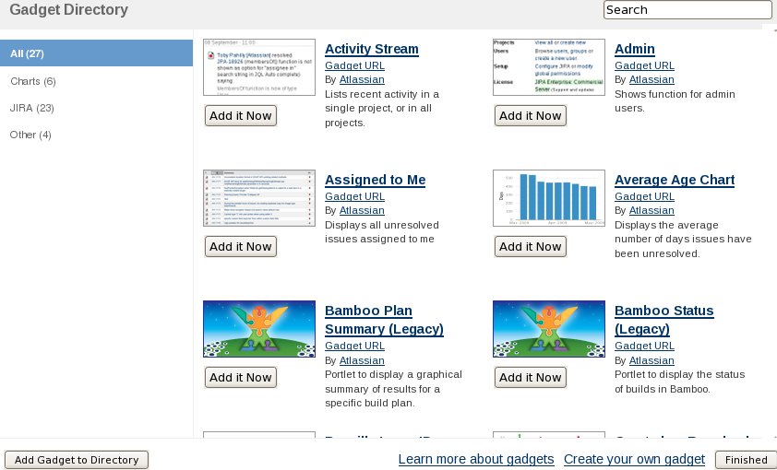
The Gadget Selector

One of the dashed boxes should have been replaced with a form titled 'Issue Statistics'.
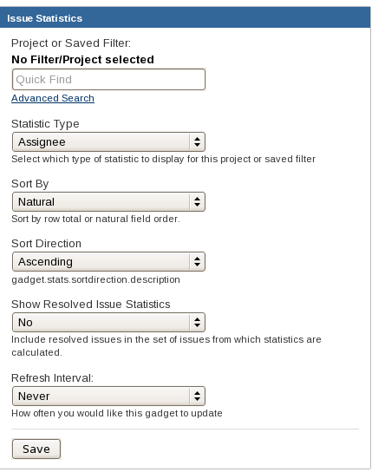
Issue Statistics
Project or Saved Filter:
Enter the name of the project or filter if known. Otherwise click 'advanced search' which opens up a window very similar to that used when setting up the 'Reports'.
Statistic Type: Status
Sort By: Natural / Total
Sort Direction: Assending/Decending
Show Resolved Issue Statistics:
Yes/No. If No is selected then the 'unresolved', 'deprecated' and 'sample published' states would not be shown.
Refresh Interval: Never/15min/30min/1hr/2hr

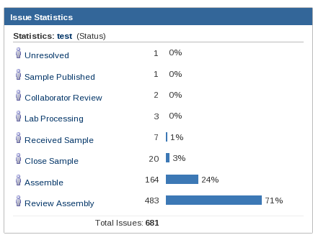
And click Save
The new Gadget

Creating a list of samples in each state:

Method 1: Search
Using the 'Samples Only' search as a starting point. Select from The 'Issues' drop-down menu the newly created 'Samples Only' filter.
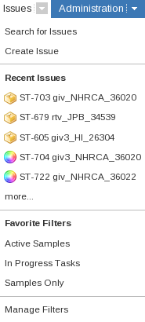

On the Issue Navigator screen; select the 'Edit' tab in the left hand Search Side-bar.
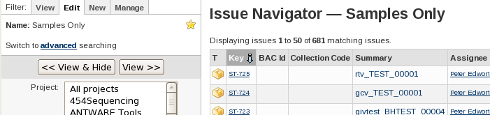

Issue Navigator (after the edit tab has been selected)

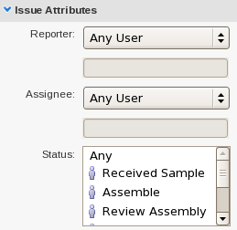
The status is set in the 'Issue Attributes' section of the Search Side-bar.

Then click 'View >>' to update the list on the right.

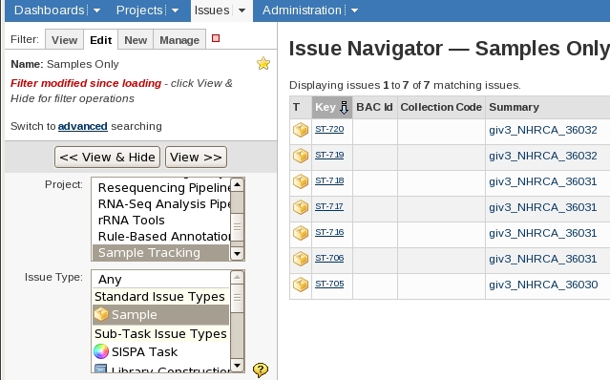
Method 2: Single Level Group By Report

Samples (IDs) in a State
ctmbacs: Gives a list of all the samples that have a given status. For each sample the BAC ID, status code and status name are listed.
JIRA: A filter can be restricted to only selecting samples with a single status. The filter can be saved to reuse later and a list of samples that matched can be produced using any of the samples fields and exported to Excel.

Bulk Update

Updating the state of a set of samples.
ctmbacs: The state of the selected samples can be set to the given state. There are no restrictions on when a sample can be in a particular state and so any sample can be given any state at anytime.
JIRA: The selected samples can have their statuses set, Restrictions in the workflow may make some state transitions impossible.

Adding a Comment
ctmbacs: The comment can be either on the command line or in a file
JIRA: The selected samples can have a comment added.

ctmbacs can both add a comment and change the state at the same time

